Aim: Program to simulate hybrid topology.

**Code:**

#include "ns3/applications-module.h" #include "ns3/core-module.h" #include "ns3/csma-module.h" #include "ns3/internet-module.h" #include "ns3/mobility-module.h" #include "ns3/network-module.h"

#include "ns3/point-to-point-module.h" #include "ns3/ssid.h"

#include "ns3/yans-wifi-helper.h"

// Default Network Topology

//

|  |  |  |  |
| --- | --- | --- | --- |
| // | | Wifi 10.1.3.0 | |
| // | | AP | |
| // | | * * * * | |
| // | | | | | | 10.1.1.0 | |
| // n5 | n6 | | n7 n0 -------------- n1 n2 n3 n4 |
| // | | point-to-point | | | | | |
| // | | ================ | |
| // | | LAN 10.1.2.0 | |

pointToPoint.SetDeviceAttribute("DataRate", StringValue("5Mbps")); pointToPoint.SetChannelAttribute("Delay", StringValue("2ms")); NetDeviceContainer p2pDevices;

p2pDevices = pointToPoint.Install(p2pNodes); NodeContainer csmaNodes; csmaNodes.Add(p2pNodes.Get(1)); csmaNodes.Create(nCsma);

CsmaHelper csma;

csma.SetChannelAttribute("DataRate", StringValue("100Mbps")); csma.SetChannelAttribute("Delay", TimeValue(NanoSeconds(6560))); NetDeviceContainer csmaDevices;

csmaDevices = csma.Install(csmaNodes); NodeContainer wifiStaNodes; wifiStaNodes.Create(nWifi);

NodeContainer wifiApNode = p2pNodes.Get(0); YansWifiChannelHelper channel = YansWifiChannelHelper::Default(); YansWifiPhyHelper phy;

phy.SetChannel(channel.Create()); WifiMacHelper mac;

Ssid ssid = Ssid("ns-3-ssid"); WifiHelper wifi; NetDeviceContainer staDevices;

mac.SetType("ns3::StaWifiMac", "Ssid", SsidValue(ssid), "ActiveProbing", BooleanValue(false));

staDevices = wifi.Install(phy, mac, wifiStaNodes); NetDeviceContainer apDevices; mac.SetType("ns3::ApWifiMac", "Ssid", SsidValue(ssid)); apDevices = wifi.Install(phy, mac, wifiApNode); MobilityHelper mobility; mobility.SetPositionAllocator("ns3::GridPositionAllocator",

"MinX",

DoubleValue(0.0), "MinY",

DoubleValue(0.0), "DeltaX", DoubleValue(5.0), "DeltaY", DoubleValue(10.0), "GridWidth", UintegerValue(3),

"LayoutType", StringValue("RowFirst"));

mobility.SetMobilityModel("ns3::RandomWalk2dMobilityModel", "Bounds",

RectangleValue(Rectangle(-50, 50, -50, 50))); mobility.Install(wifiStaNodes); mobility.SetMobilityModel("ns3::ConstantPositionMobilityModel"); mobility.Install(wifiApNode);

InternetStackHelper stack; stack.Install(csmaNodes); stack.Install(wifiApNode); stack.Install(wifiStaNodes); Ipv4AddressHelper address; address.SetBase("10.1.1.0", "255.255.255.0");

Ipv4InterfaceContainer p2pInterfaces; p2pInterfaces = address.Assign(p2pDevices); address.SetBase("10.1.2.0", "255.255.255.0");

Ipv4InterfaceContainer csmaInterfaces; csmaInterfaces = address.Assign(csmaDevices); address.SetBase("10.1.3.0", "255.255.255.0");

address.Assign(staDevices); address.Assign(apDevices); UdpEchoServerHelper echoServer(9);

ApplicationContainer serverApps = echoServer.Install(csmaNodes.Get(nCsma)); serverApps.Start(Seconds(1.0));

serverApps.Stop(Seconds(10.0));

UdpEchoClientHelper echoClient(csmaInterfaces.GetAddress(nCsma), 9); echoClient.SetAttribute("MaxPackets", UintegerValue(1)); echoClient.SetAttribute("Interval", TimeValue(Seconds(1.0))); echoClient.SetAttribute("PacketSize", UintegerValue(1024));

ApplicationContainer clientApps = echoClient.Install(wifiStaNodes.Get(nWifi - 1)); clientApps.Start(Seconds(2.0));

clientApps.Stop(Seconds(10.0)); Ipv4GlobalRoutingHelper::PopulateRoutingTables(); Simulator::Stop(Seconds(10.0));

if (tracing)

{

phy.SetPcapDataLinkType(WifiPhyHelper::DLT_IEEE802_11_RADIO); pointToPoint.EnablePcapAll("third");

phy.EnablePcap("third", apDevices.Get(0));

csma.EnablePcap("third", csmaDevices.Get(0), true);

}

Simulator::Run(); Simulator::Destroy(); return 0;

}

**Output:**

Step1: open example folder

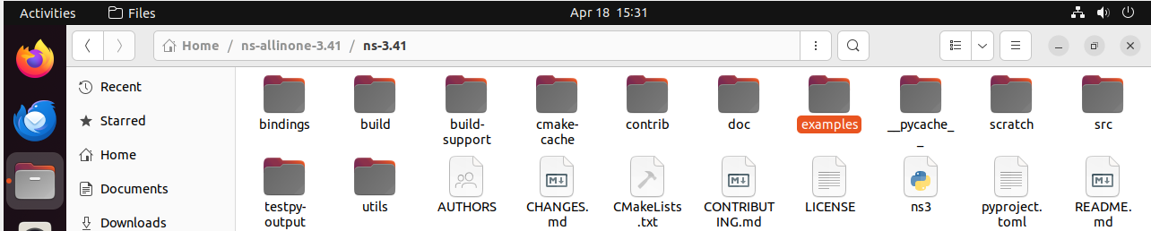

Step2: copy the third.cc file

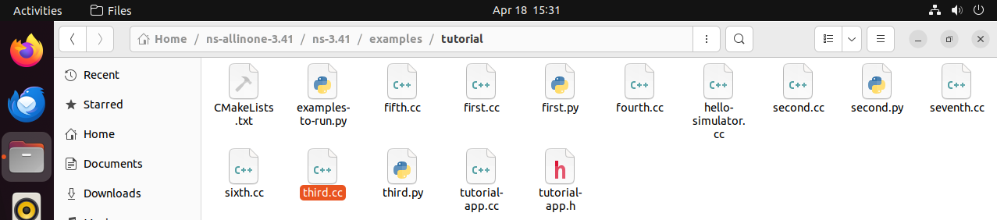

Step3: come back to ns-3.41 and open scratch folder and paste the third.cc here

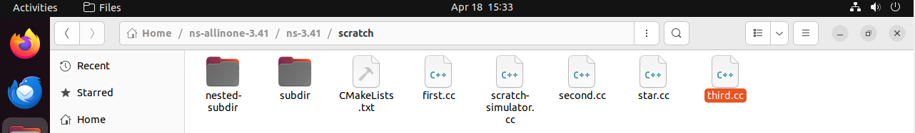

Step4: Back to ns-3.41 file click on 3 dot it gives the option for open terminal run the command ./ns3 run scratch/third

